THINKING ABOUT STEWARDSHIP
We, as Catholics, give to the Lord because we are grateful. The giving of ourselves in totality – body, mind, spirit, talents, time and material resources – is our way of expressing our thankfulness to God for all that we have. Responding to the immeasurable love and grace of God, dedicated Catholics open their hearts and hands toward God in a spirit of appreciation and love.

This teaching ministry may be achieved by VOLUNTEERING as

- Classroom Catechist or Co-Catechist
- Catechist’s Aide or Helper
- Substitute Catechist

REQUIRED: All Volunteers MUST ATTEND the VIRTUS Program (Protecting God’s Children) provided by the Archdiocese of Hartford and fill out a background check before anyone can volunteer.

If you are interested in sharing your time and talent with our youth in this ministry, please call the office and leave a
message at 283-5817, or email me at roxy@stmkp.org



Jesus Loves Us Always

Revised 7-11-24
St. Maximilian Kolbe Parish
Religious Education
Policy and Procedures

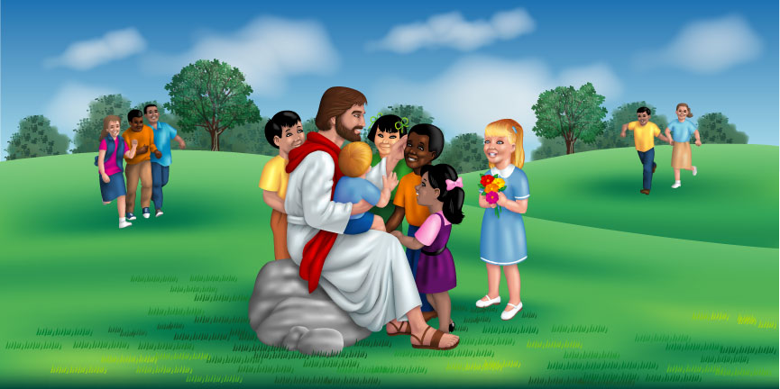

"Jesus said “Let the children come to me”

Mission Statement
It is the mission of St. Maximilian Kolbe Parish Office of Religious Education to educate the children and adults of this parish in the teachings and traditions of the Roman Catholic Church so that we can live our faith and follow in the footsteps of Jesus.

Religious Education
Policies and Procedures for
Parents and Students

Welcome

Please take a few minutes to review the parent and student Policies and Procedures handbook. It is very important that you confirm that you have read, understand and agree to the above Religious Education Policies and Procedures and have discussed them with your child.
Located on the bottom rear on the back of the registration form is a place for your signature. This serves as confirmation that you have read the handbook and explained the policies and procedures to your child. You and your child agree to do what the program asks of you.

Additional registration forms can be downloaded from our web site at http://stmkp.org/religious-education/

The Office of Religious Education
The Office of Religious Education is located in St. Maximilian Kolbe Parish office in the St. Thomas School building.

Meetings with the office of Religious Education staff can be made by appointment. You can call the Parish office at 860-283-5817.

Religious Education Office
Phone..............860-283-5817 Ext. 405

E-mail ………. roxy@stmkp.org

St. Maximilian Kolbe Parish Website: www.stmkp.org

Safety and Health
- In the case of a fire drill, each catechist has a plan for the safe evacuation of their classroom. Students will be informed of the plan at the beginning of the school year.
- Make sure you fill out the student “allergies” section of the registration, so the catechist can be notified.
- The Religious Education curriculum includes a program called Lures. This teaches our children age-appropriate personal safety. It is introduced in first grade and continues to be taught every year. It is a requirement of the Archdiocese of Hartford.
- St. Maximilian Kolbe Religious Education program will be “food free”. Meaning there will be NO food, gum, candy, etc. allowed during regularly scheduled classes. Stickers, pencils, or any non- food items are always welcomed.

Child Abuse/Safe Environment Program
Virtus - Protecting God’s Children

Child abuse is a serious concern. Consistent with diocesan policy and local legal codes, the parish catechetical staff has a moral and legal duty to comply with the law to ensure the welfare of a child. Pursuant to state law, we are required to report suspected child abuse, and we will also follow diocesan policy on such matters.

Volunteers
We are currently planning this year’s program. To ensure its success, we need an adequate number of Religious Education Catechists and aides. Volunteers are the backbone of our program. The requirements are: you must be a practicing Catholic (training & teaching materials will be available to anyone interested), attend Virtus training- (Protecting God’s Children) and submit a background check form before beginning in this ministry.

Discipline
Our program is in a school setting. Even in the best circumstances, very few hours of instruction are given each year. Misbehavior will not be tolerated. Running, sliding and general horseplay is not appropriate behavior and will not be allowed.

Catechists will instruct the students on the first day of classroom rules and behavior. Each time a student misbehaves, the catechist will instruct the student of the rules. Upon the third warning the student will be sent to the Directors office. Students that are sent to the office two times will be removed from classes until the director has had a meeting with the parents. If after this meeting and misbehavior still occurs, the parents, director and the Parish Priest will meet to resolve the problem.

Attendance Policy
It is required that students attend all classes, masses, retreats, special services and service projects. If on a rare occasion, one must be absent from class or another scheduled activity, parents must notify the Religious Education Office that they will be absent. If a student misses a class or other scheduled occasions, make up work will be given.



Registration
The registration fees that are collected help pay for student books, bibles, supplies and other materials needed to run our program for the year.

Registration Fee $45.00/child, $95.00/ (Family = 3 or more children) A Census card must be filled out by all families who attend religious education and kept on file in the Parish Center. Classes begin in September and parents will be notified by e-mail 1 to 2 months before classes begin. Notification will also be placed on our website under Religious Education. Please make check payable to: St. Maximilian Kolbe Parish

It is very important to return your forms with all the necessary information completed, along with your registration fees as soon as possible.

Day and Locations
Sunday ……. St. Thomas School Building …Thomaston
Sunday ……… The Lyceum …… Terryville
Grades K-10th

It is very important that classes start on time. Children should arrive no less than 5 minutes and no more than 15 minutes before classes begin
Times are listed on your registration forms and on our website. Class times can change year to year.

Cancellation of Classes
Please look at TV Channel 3, 4, 6 & 8 for religious education cancellations. You can also check the website of each TV station; announcements of closings will be posted. A religious education cancellation does not cancel church masses.

Student Books and Bible
Every student receives some type of textbook in grades K-10. Students are given a Bible in the 6th grade in addition to their textbook.

Please write your child’s name, grade, and catechist’s name on the inside front cover of the book. This helps us in returning lost books to their rightful owners.

Bibles and textbooks should be brought to class every week of Religious Education. (Bibles for 6th to 10th grade)

Parents
The Roman Catholic Church has for centuries taught that it is primarily the duty of parents to see to the Baptism and education of their children in the faith. As that is a very difficult task due to the many demands put on people who raise families, parishes have long offered systems to help them. Still, no matter how supportive these systems are, they remain nothing more than aids to help parents in the education of their children. If children learn to pray, if they learn the teachings of their faith, if they love and frequent the sacraments, if they practice Christ’s teachings in their lives; it is only because their parents have been faithful to their God given vocation of being a Catholic parent.

Parents who take advantage of the education offered by the parish for their families thereby accept several responsibilities:

- Participate in Sunday Mass and Holy Days with their children. The Roman Catholic Church teaches, and our program in turn teaches, that every Roman Catholic should attend Sunday Mass. If parents do not attend Mass, they confuse their children - not only about the authority of the church and their catechists regarding Mass attendance, but in other areas as well.

- Parents will ensure their children’s faithful attendance at classes and other activities such as prayer services, retreats and service projects.
- Parents will attend meetings with the coordinator before the reception of the sacraments of First Reconciliation, First Holy Communion and Confirmation. Attendance at the scheduled parents meeting is required.

Dropping off and picking up your children
All scheduled activities within the Religious Education program will begin at the noted times (see schedules). Do not drop off a student without first confirming that there is Supervision present.

ALL students must be picked up by a parent or guardian in the designated building area.

Please park your vehicles in the building parking lots, or in a legal side street parking space. When parking, please park in an orderly fashion, so that cars can come and go easily. Parents should arrive BEFORE dismissal so those students can be picked up PROMPTLY and safely. These policies may change to provide for the safety of the students.

Sacramental Requirements
All requirements for reception of sacraments must be fulfilled at least two weeks prior to the Sacramental date. All candidates must have had the sacrament of Baptism before receiving the following Sacraments. Requirements are listed in the Sacramental handbooks for each. (Sacramental handbooks will be given out at the appropriate times)

The Sacrament of First Reconciliation is in grade 2.
The Sacrament of First Communion is in grade 2.
The Sacrament of Confirmation is in grade 10.

